Genetic Algorithms
Section #7
Constraint Satisfaction Problem (CSP)
Nurse Scheduling Problem )NSP)
Imagine you are responsible for scheduling the shifts for the nurses in your hospital department for this week. There are three shifts in a day – morning, afternoon, and night and for each shift, you need to assign one or more of the eight nurses that work in your department. If this sounds like a simple task, take a look at the list of relevant hospital rules:
- A nurse is not allowed to work two consecutive shifts.
- A nurse is not allowed to work more than five shifts per week.
- The number of nurses per shift in your department should fall within the following limits:
- Morning shift: 2–3 nurses
- Afternoon shift: 2–4 nurses
- Night shift: 1–2 nurses
In addition, each nurse can have shift preferences. For example, one nurse prefers to only work morning shifts, another nurse prefers to not work afternoon shifts, and so on.

This task is an example of the nurse scheduling problem (NSP), which can have many variants. Possible variations may include different specialties for different nurses, the ability to work on cover shifts (overtime), or even different types of shifts – such as 8-hour shifts and 12-hour shifts

By now, it probably looks like a good idea to write a program that will do the scheduling for you. Why not apply our knowledge of genetic algorithms to implement such a program? As usual, we will start by representing the solution to the problem.

Solution representation:-
For solving the nurse scheduling problem, we decided to use a binary list (or array) to represent the schedule as it will be intuitive for us to interpret, and we've seen that genetic algorithms can naturally handle this representation.
For each nurse, we can have a binary string representing the 21 shifts of the week. A value of 1 represents a shift that the nurse is scheduled to work on. For example, take a look at the following binary list:
(0, 1, 0, 1, 0, 1, 0, 1, 1, 0, 0, 0, 0, 0, 1, 1, 0, 0, 0, 1, 0)
This can be broken into the following groups of three values, representing the shifts this nurse will be working each day of the week:
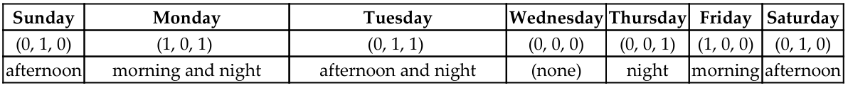
Note :- The schedules of all nurses can be then concatenated together to create one long binary list representing the entire solution.

Evaluating a solution:-
this long list can be broken down into the schedules of the individual nurses, and violations of the constraints can be checked for:-
- The preceding sample nurse schedule, for instance, contains two occurrences of consecutive 1 values that represent consecutive shifts being worked (afternoon followed by night, and night followed by morning).
- The number of weekly shifts for that same nurse can be calculated by totaling the binary values of the list, which results in 8 shifts.

Difference between hard & soft constraints:-
In the case of the N-Queens problem, all the constraints – row, column, and diagonal – were hard constraints. Had we not found a solution where the number of violations was zero, we would not have a valid solution for the problem. Here, on the other hand, while the hospital rules are considered hard constraints, the nurses' preferences are soft constraints. So, we are actually looking for a solution that will not violate any of the hospital rules while minimizing the number of breaches to the nurses' preferences.

NSP Implementation:-
import random
import numpy as np
import matplotlib.pyplot as plt

NUM_NURSES = 4
DAYS = 5

# 0 = Off, 1 = Morning, 2 = Evening, 3 = Night
SHIFTS = [0, 1, 2, 3]

MAX_SHIFTS = 4
POP_SIZE = 20
GENERATIONS = 50

def create_individual():
return np.random.choice(SHIFTS, size=(NUM_NURSES, DAYS))

def fitness(individual):
penalty = 0

# Constraint 1: max shifts per nurse
for nurse in individual:
work_days = np.count_nonzero(nurse)
if work_days > MAX_SHIFTS:
penalty += (work_days - MAX_SHIFTS) * 2

# Constraint 2: at least one working nurse per day
for day in range(DAYS):
if np.all(individual[:, day] == 0):
penalty += 5

return -penalty

def select(population):
return max(random.sample(population, 3), key=fitness)

def crossover(parent1, parent2):
point = random.randint(1, DAYS - 1)
child = np.hstack((parent1[:, :point], parent2[:, point:]))
return child

def mutate(individual):
if random.random() < 0.3:
nurse = random.randint(0, NUM_NURSES - 1)
day = random.randint(0, DAYS - 1)
individual[nurse][day] = random.choice(SHIFTS)
return individual

def run_ga():
population = [create_individual() for _ in range(POP_SIZE)]
fitness_history = []

for gen in range(GENERATIONS):
new_population = []

for _ in range(POP_SIZE):
p1 = select(population)
p2 = select(population)

child = crossover(p1, p2)
child = mutate(child)

new_population.append(child)

population = new_population

best = max(population, key=fitness)
best_fit = fitness(best)
fitness_history.append(best_fit)

print(f"Generation {gen}: Fitness = {best_fit}")

return best, fitness_history

def visualize_schedule(schedule):
plt.imshow(schedule, aspect='auto')
plt.title("Nurse Scheduling Heatmap")
plt.xlabel("Days")
plt.ylabel("Nurses")
plt.colorbar(label="Shift (0=Off,1=M,2=E,3=N)")
plt.show()

visualize_schedule(best_solution)

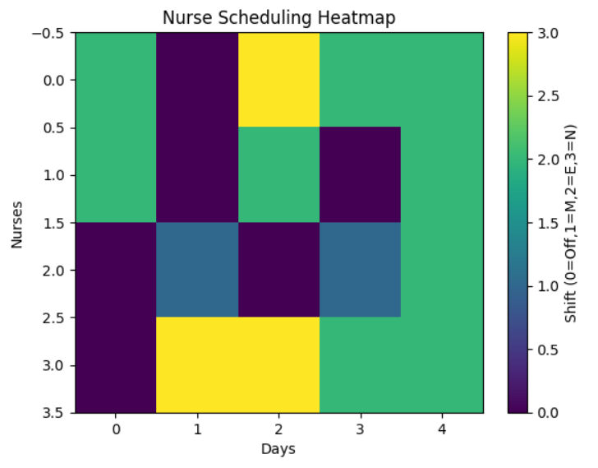
plt.plot(history, marker='o')
plt.title("Fitness Over Generations")
plt.xlabel("Generation")
plt.ylabel("Fitness")
plt.grid()
plt.show()

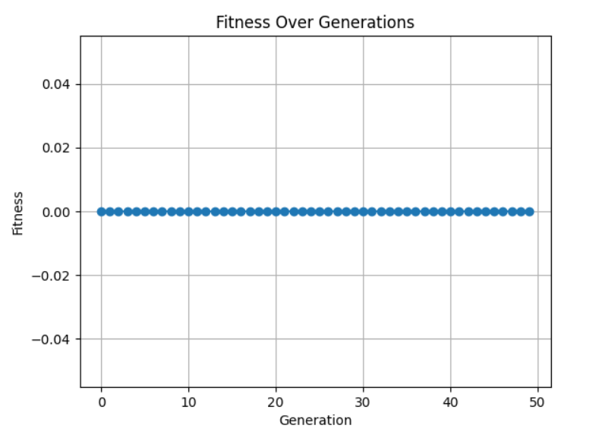
best_gen = history.index(max(history))
print("Best solution found at generation:", best_gen)
plt.plot(history)
plt.axvline(x=best_gen, linestyle='--')
plt.title("Best Solution Point")
plt.show()
